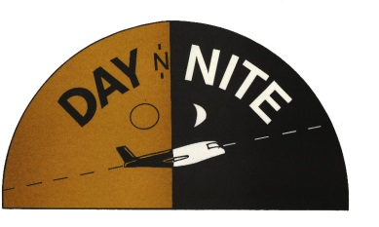
AIR & MESSENGER SERVICE
LOCAL MESSENGER RATES

LAKE MICHIGAN (EAST) OHIO AVE.(NORTH) HARRISON ST.(SOUTH) JEFFERSON ST(WEST)
CHICAGO LOOP SPECIAL****$4.00 / CAR $10.50

MILES BLOCK REGULAR RUSH EMERG. FLASH (4 HR) (2 HR) (1 HR) (ASAP) LOOP
1 8 SEE ABOVE PROMOTION
2 16 8.50 10.50 12.50 16.50
3 24 10.50 11.50 14.50
4 32 12.50 12.50 16.50
5 40 14.00 16.50 18.50
6 48 16.00 18.50 20.50
7 56 18.00 20.50 22.50
8 64 20.00 22.50 24.00
9 72 22.00 24.50 26.00
10 80 25.00 26.50 28.00
11 88 26.00 28.50 30.00
12 96 27.00 30.50 32.00
13 104 28.00 32.50 34.00
14 112 29.00 34.40 36.00
15 120 30.00 36.50 38.00
16 128 31.00 38.50 40.00
**REGULAR DELIVERY (4 HRS) SUBURBAN RATES
**RUSH DELIVERY (2 TO 3 HRS) $20.00 ADDITIONAL
**EMERGENCY DELIVERY (2 HRS) $30.00 ADDITIONAL
**WAITING TIME $15.00 PER HOUR
**EXCESS WEIGHT (OVER 20 POUNDS) $ .10 PER POUND
**PICKUP CHARGE TIME AND A HALF
**ROUNDTRIP DELIVERIES TIME AND A HALF
**SATURDAY DELIVERIES TIME AND A HALF
**SUNDAY / HOLIDAY DELIVERIES DOUBLE THE REGULAR CHARGE
**VAN SERVICE $25.00 ADDITIONAL
**SPECIAL IN HOUSE SERVICE $40.00 PER HOUR

