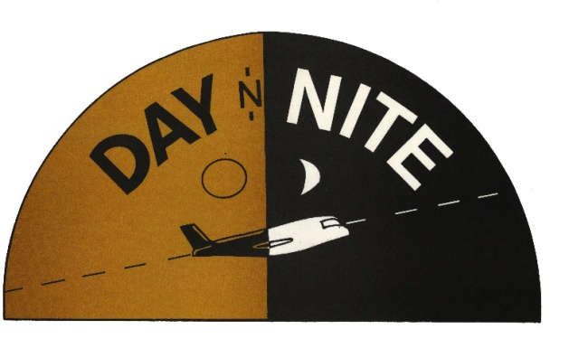

AIR COURIER RATES

***DELIVER TO ANY DESTINATION IN THE U.S.***

Letter***** NEXT DAY $ 40.00 3:00 PM $ 35.00 TWO-DAY $ 30.50

NEXT DAY 3:00 PM TWO-DAY NEXT DAY 3:00 PM TWO-DAY
1 LB. $ 50.00 $ 45.00 $ 30.00 6 LBS 80.00 $ 75.00 $ 65.00
2 LBS $ 55.00 $ 50.00 $ 40.00 7 LBS 95.00 $ 90.00 $ 80.00 3 LBS $ 60.00 $ 55.00 $ 45.00 8 LBS 100.00 $ 95.00 $ 85.00
4 LBS $ 65.00 $ 60.00 $ 50.00 9 LBS 105.00 $ 100.00 $ 90.00 5 LBS $ 70.00 $ 65.00 $ 55.00 10 LBS 110.00 $ 105.00 $95.00

**GROUND SERVICE 1LB. $15.00 / ADDTIONAL $1.00 EACH LBS

*** NEXT DAY**EACH ADDITIONAL POUND $ 4.50**
***3:00PM**EACH ADDITIONAL POUND $3.00****
***TWO-DAY**EACH ADDITIONAL POUND $2.75****
***9AM SERVICE – ADDITIONAL $ 75.00****
***SATURDAY DELIVERY – ADDITIONAL $60.00****

ADDITIONAL DISCOUNT AVAILBLE FOR LOCAL MESSENGER SERVICE AND OVERNITE DELIVERIES

DAY N NITE INC
107 WEST VAN BUREN ST
CHICAGO ILLINOIS 60606
312-663-1342
WEBSITE: www.daynnite.net
INFO: daynnite.messenger@gmail.com

