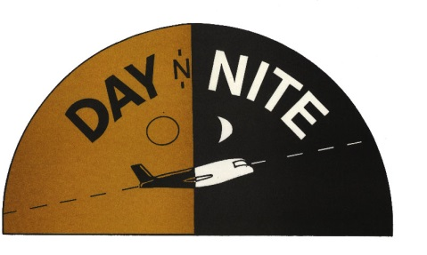
AIR & MESSENGER SERVICE

ADDITIONAL SPECIAL SERVICES

ADDRESS CORRECTION ADDITIONAL CHARGES APPLY FOR ADDRESS CORRECTION, REDELIVERED PACKAGES AND RETURN PACKAGES.

THIRD PARTY PICKUPS THERE WILL BE A SERVICE FEE FOR THIRD PARTY PICKUP OF $5.00 PER PACKAGE.

PICKUP CONDITIONS IN ORDER TO SCHEDULE A PICKUP, DNN ACCOUNT NUMBER IS REQUIRED. THERE IS NO CHARGE FOR DAILY SCHEDULED PICKUP SERVICE.

SECOND PICKUP PLEASE CALL CUSTOMER SERVICE AS SOON AS POSSIBLE IF YOU NEED AN ADDITIONAL PICKUP.

DELIVERY CONDITIONS SHIPMENTS MAY BE DROPPED WITHOUT A SIGNATURE IF YOU MARK IT ON THE AIRBILL, OR CALL CUSTOMER SERVICE AND GIVE VERBAL AUTHORIZATION. WE WILL NOT ACCEPT LIABILITY FOR A CLAIM IF WE DO NOT HAVE AUTHORIZATION.

SPECIAL DELIVERY SATURDAY AND SUNDAY DELIVERIES MUST BE CLEARLY MARKED ON THE AIRBILL, AND IF POSSIBLE ON THE PACKAGES.

SERVICE GUARANTEE DNN MUST BE NOTIFIED IN WRITING WITHIN TEN BUSINESS DAYS FROM THE DATE OF THE SHIPMENT IF YOU ARE GOING TO FILE A CLAIM. ANY CLAIM FILED AFTER TEN BUSINESS DAYS FROM THE DATE OF THE SHIPMENT, DNN RESERVES THE RIGHT TO REFUSE THAT CLAIM.
DNN WILL NOT ACCEPT LIABLITY FOR FAILING TO MEET OUR DELIVERY GUARANTEE DUE TO AN INCORRECT ADDRESS OR THE CONSIGNEES REFUSAL TO ACCEPT THE SHIPMENT.
DNN GUARANTEE DOES NOT APPLY FOR SHIPMENTS DELAYED BY CONDITIONS BEYOND OUR CONTROL, INCLUDED BUT NOT LIMITED TO: ACTS OF GOD, PERILS OF THE AIR, LAND AND SEA, AIRLINE DELAYS, WEATHER CONDITIONS, ACTS OF PUBLIC ENEMIES, WAR, STRIKES, CIVIL COMMOTION OR ACTS OR OMISSIONS OF PUBLIC AUTHORITIES INCLUDING CUSTOMS AND HEALTH OFFICIALS WITH ACTUAL OR APPARENT AUTHORITY.

DECLARED VALUE CONDITIONS UNLESS A GREATER VALUE HAS BEEN DECLARED ON THE AIRBILL, DNN MAXIMUM LIABILITY WILL BE $100.00. WE WILL NOT ACCEPT LIABILITY FOR ANY SHIPMENT THAT WAS AUTHORIZED TO LEAVE WITHOUT A SIGNATURE.

BILLING AND TERMS DNN WILL BILL YOUR ACCOUNT WEEKLY AND THE PAYMENT IS DUE WITHIN SEVEN DAYS. ANY BILLING ERRORS MUST BE REPORTED WITHIN 15 DAYS OF THE DATE OF THE INVOICE.

